**IOT LAB**

**Program No - 10**

**Program Title – VIBRATION MOTOR AND LED.**

**Aim – To design and automated day indicator system.**

**Hardware Required -**

* Arduino Board
* Bread board
* Resistor
* Photoresistor
* Vibration motor
* Temperature sensor
* Multimeter

**Circuit Diagram –**

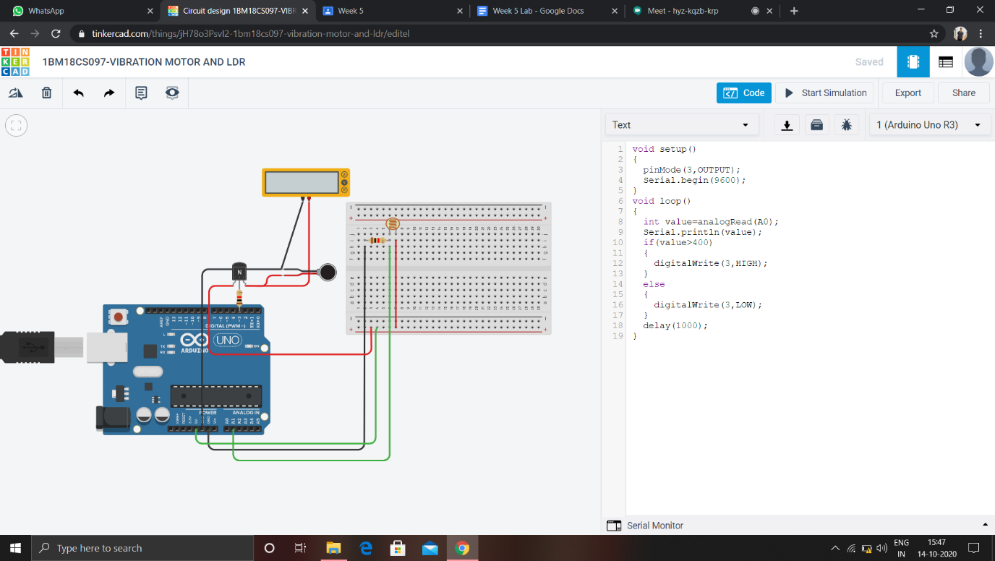

**Code:**

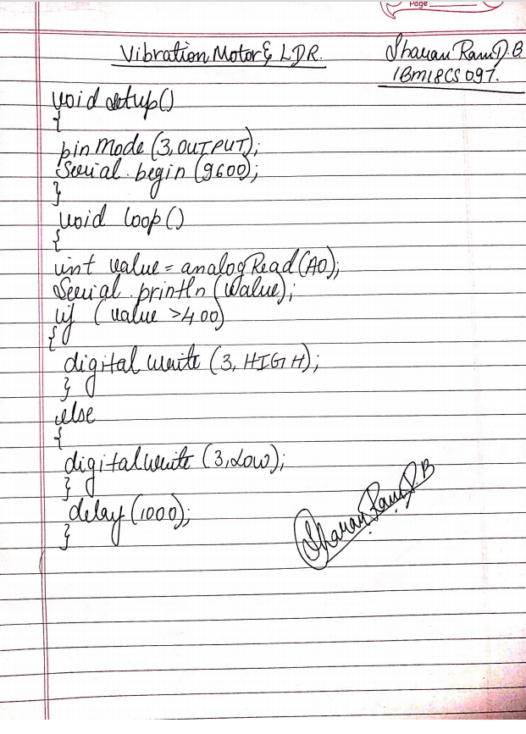

**Observation /Output –**

**The vibrator starts vibrating as the light brightness increases.**